**INTIMIDATORS**

**WireFrames for Frontend Design**

1. **AICTE main portal**

**LOGIN/REGISTER**

**BUTTON**

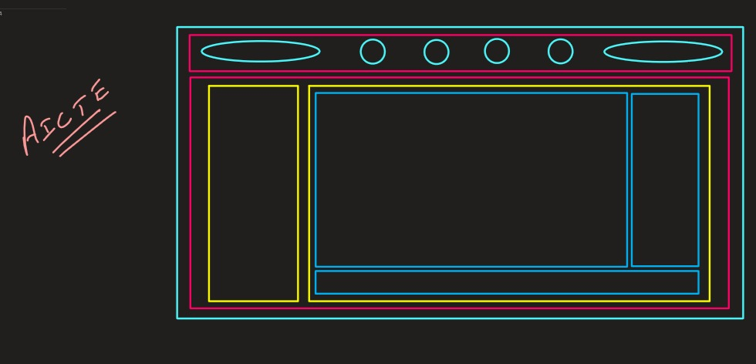

**SUBMENU CHANGES ACC TO MENU**

**MAIN CONTENT GOES HERE**

**WHICH WILL RENDER ACC TO SUBMENU**

**MENU FOR AICTE CONTENT**

**FOOTER**

1. **AFDP main portal**

**LOGIN/REGISTER**

**BUTTON**

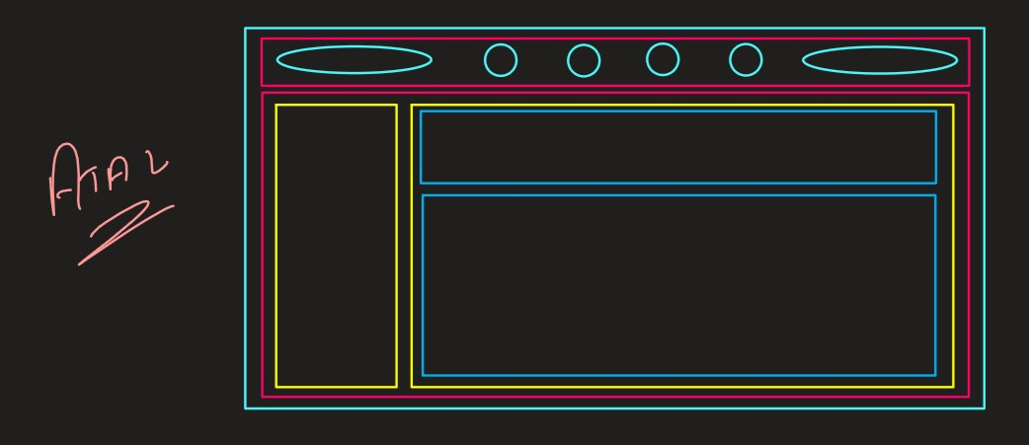

**HEADING**

**MAIN CONTENT GOES HERE**

**WHICH WILL RENDER ACC TO MENU**

**MENU FOR AFDP CONTENT**

1. **SOCIAL MEDIA portal**

**LOGIN/REGISTER**

**BUTTON**

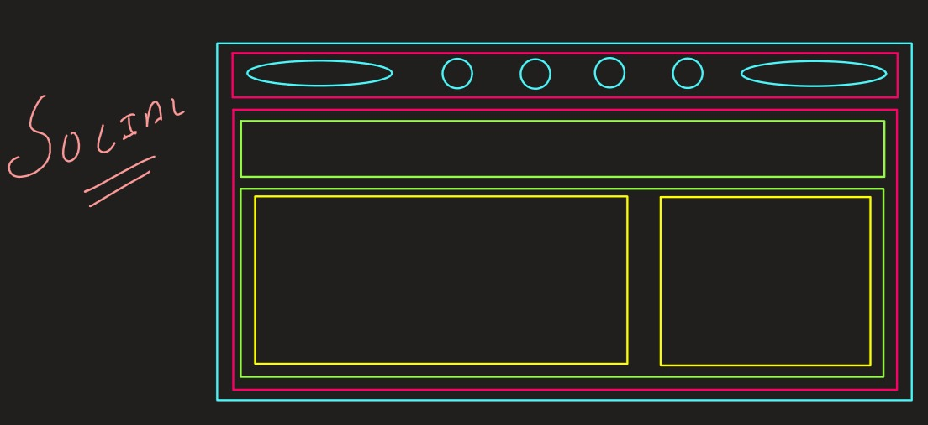

**HEADING**

**TEXT**

**THAT IS POSTED**

**VIDEO / IMAGES**

**THAT IS POSTED**

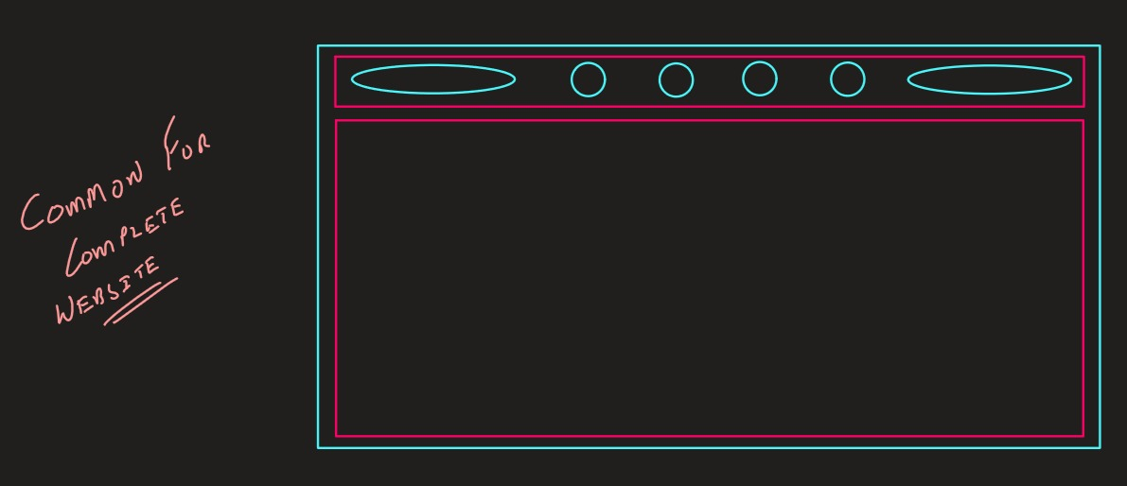

**PORTALS WILL RENDER HERE ACC TO MENU**

**SCHEMA for Backend**

**UseCase Diagram**

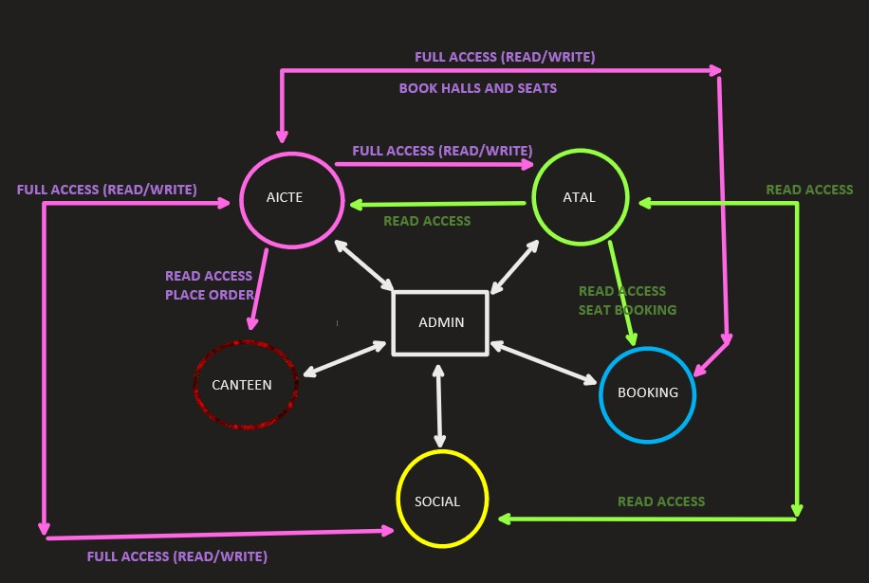

**Detailed Scheme**

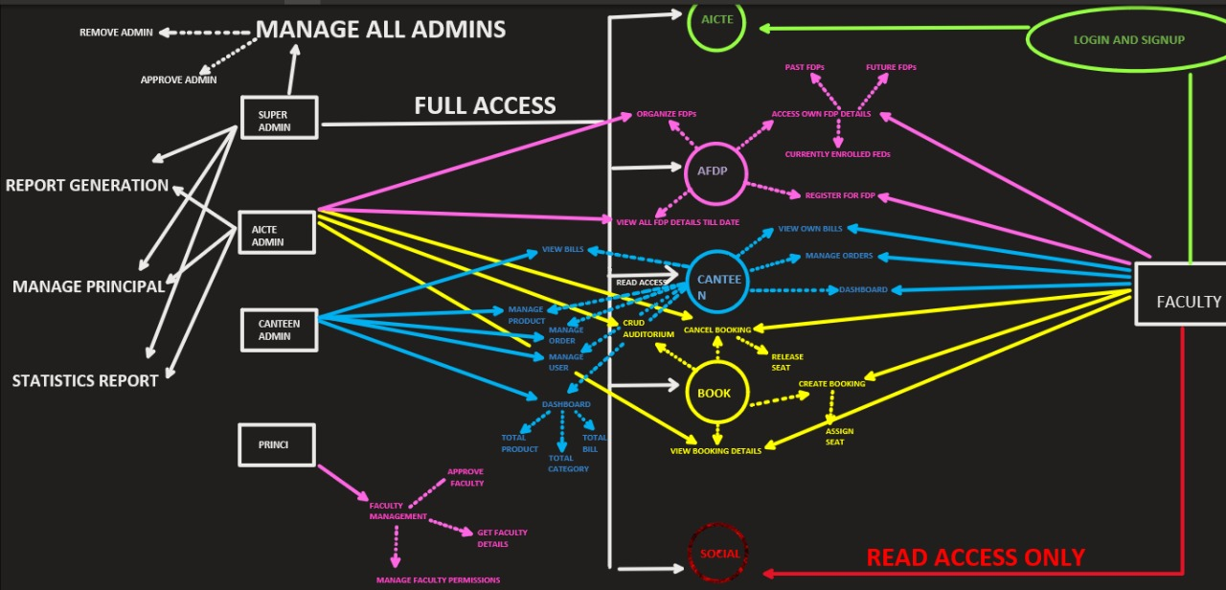

**Database Connectivity**

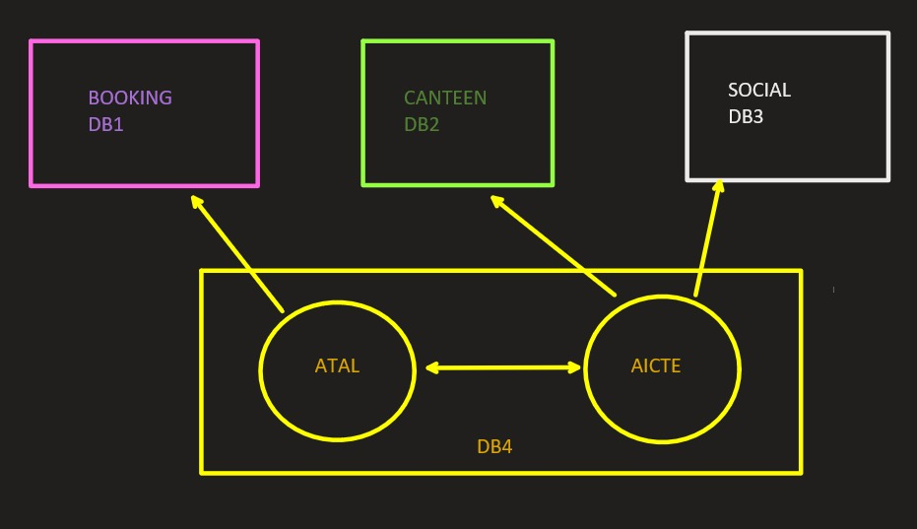

**Canteen management**

**Social media**

**Meeting**

**Cinema booking(seats)**

**Aictc , fdp**

**FRONTEND WILL LOOK LIKE**

[](https://www.youtube.com/embed/oNKsJD2fmm4?feature=oembed)